Phoenix Climate

Employing NASA Earth Observations to Conduct Site Suitability Analyses on Residential Tree Planting Initiatives in Phoenix, AZ

 **Technical Report**

Final – March 31st, 2022

Alison Bautista (Project Lead)

Haley Stuckmeyer

Gloria Liu

Ben Schafermeyer

***Advisors:***

Dr. David Hondula, Arizona State University & City of Phoenix (Science Advisor)

Lance Watkins, Arizona State University (Science Advisor)

# 1. Abstract

Phoenix, Arizona is the hottest city in the United States, with daytime summer temperatures consistently reaching upwards of 100°F. As these daytime temperatures continue to climb, heat-related illnesses and morbidity also increase. The City of Phoenix hopes to secure funding to implement the American Rescue Plan Act (ARPA) residential tree equity accelerator program. This funding will be used for targeted investments in underserved neighborhoods to increase tree canopy cover, engaging 5,000 households across selected neighborhoods. By partnering with the City of Phoenix, the Arizona Office of Heat Mitigation, and Arizona State University’s Urban Climate Research Center, our team identified residential neighborhoods, block groups within qualified census tracts, and parcels to be prioritized in the ARPA program. We conducted an analysis using NASA Earth observations, movement and heat exposure data, sociodemographic data, and tree canopy data. For Earth observations, we acquired daytime land surface temperature from the Landsat 8 Operational Land Imager (OLI) and Thermal Infrared Sensor (TIRS) and land cover classification from the United States Geological Survey (USGS) National Land Cover Database (NLCD). The project will support the prioritization of city resources and tree plantings based on community vulnerability, as well as help initiate public engagement efforts and literacy with an interactive dashboard and GIS layers that contribute to the city’s property information portal.

**Key Terms**

urban heat, environmental justice, LST, tree equity

# 2. Introduction

***2.1 Background Information***

Human relationships to the environment have been characterized by control; we have opted to slash and remove the wilderness from our ecosystems as a means of survival and profit. As anthropogenic activity increases, vegetation is removed from urban environments and replaced by impermeable surfaces with lower albedo, lower potential for evaporative cooling, and higher thermal storage capacity. These surfaces contribute to a lack of thermal comfort, higher energy consumption, and slower cooling of urban areas overnight (Martilli et al., 2020). In arid cities like Phoenix, AZ that have historically relied on cooler night temperatures, this lag in nighttime cooling has increased the energy demand for mechanical cooling overnight (Golden, 2004). Urban heat mitigation strategies, such as the expansion and management of the urban tree canopy, are a promising tool to reduce the impact of increasing temperature. Like lawns and shrubs, trees contribute to cooling by releasing energy in the form of evapotranspiration instead of storing heat like impervious surfaces. Unlike lawns and shrubs, trees also decrease radiation exchange below the canopy (Wang et al., 2016). In addition to lowering air temperature, extensive urban forests aid in enhancing other aspects of environmental quality by removing certain air pollutants, sequestering carbon, and improving groundwater quality (Nowak et al., 2007).

The effects of urban heat disproportionally impact communities in Phoenix which have fewer resources available to help them cope with summer temperatures (Harlan et al., 2013). Vulnerability to extreme heat has been linked to areas with high poverty and a higher proportion of nonwhite residents, both associated with a higher risk of heat-related mortality (Maier et al., 2014). Additionally, areas of high poverty and high concentration of racial and ethnic minority residents tend to have less green space coverage and greater distances to the nearest green spaces on average (Wen et al., 2013). These disparities must be addressed in order to equitably alleviate urban heat in Phoenix and ensure environmental justice.

Environmental justice focuses on creating healthy and clean environments, especially for those who have traditionally lived, worked, and played closest to the sources of pollution. It is centered on the “fair treatment and meaningful involvement of all people regardless of race, color, national origin, culture, education, or income...” (NASA, 2020). Environmental justice demands social justice, equal access to a clean and healthy environment, and an end to institutional discrimination. Incorporating an environmental justice framework within city planning and development initiatives can help inform the City of Phoenix which areas need to be prioritized when implementing heat-mitigation strategies.

Recent urban heat studies have heavily relied on remote sensing capabilities due to ease of use, affordability, and timeliness compared to other climatic and temperature data sources (Mitraka & Chrysoulakis, 2018). *In situ* meteorological observations provide valuable on-the-ground information, but the urban climate varies greatly block to block. Remote sensing allows for the broader temporal and spatial analysis that is necessary to identify patterns in the urban climate, as well as concurrent analysis of factors that influence microclimate like land cover. Harlan et al. (2013) provides evidence that place-based vulnerability leads to heat-related death, and advocates for the use of surface temperature to aid in determination of neighborhood heat vulnerability. This study showed large variation in heat vulnerability throughout Phoenix neighborhoods, which underscores the importance of remote sensing and utilization of Earth observations to assess heat impacts in urban areas. Our efforts to aid the City of Phoenix focused on translating these principles of urban heat research to the implementation of a specific heat mitigation strategy using NASA Earth observations.

Phoenix is the 5th largest city in the United States, with a population of 1.6 million people in 2020 and growing (US Census, 2020). To address heightened concerns over urban heat, the city has proposed a Residential Tree Equity Accelerator program that seeks to mitigate urban heat by increasing shade within residential areas. To aid in the City of Phoenix’s efforts to increase tree canopy coverage, the NASA DEVELOP Phoenix Climate team created heat vulnerability, tree equity, and social vulnerability indices. These indices utilize environmental data, demographic data, and NASA Earth observations. These data were gathered over a period of 5 years, from 2015 to 2019, within Phoenix city boundaries (Figure 1).

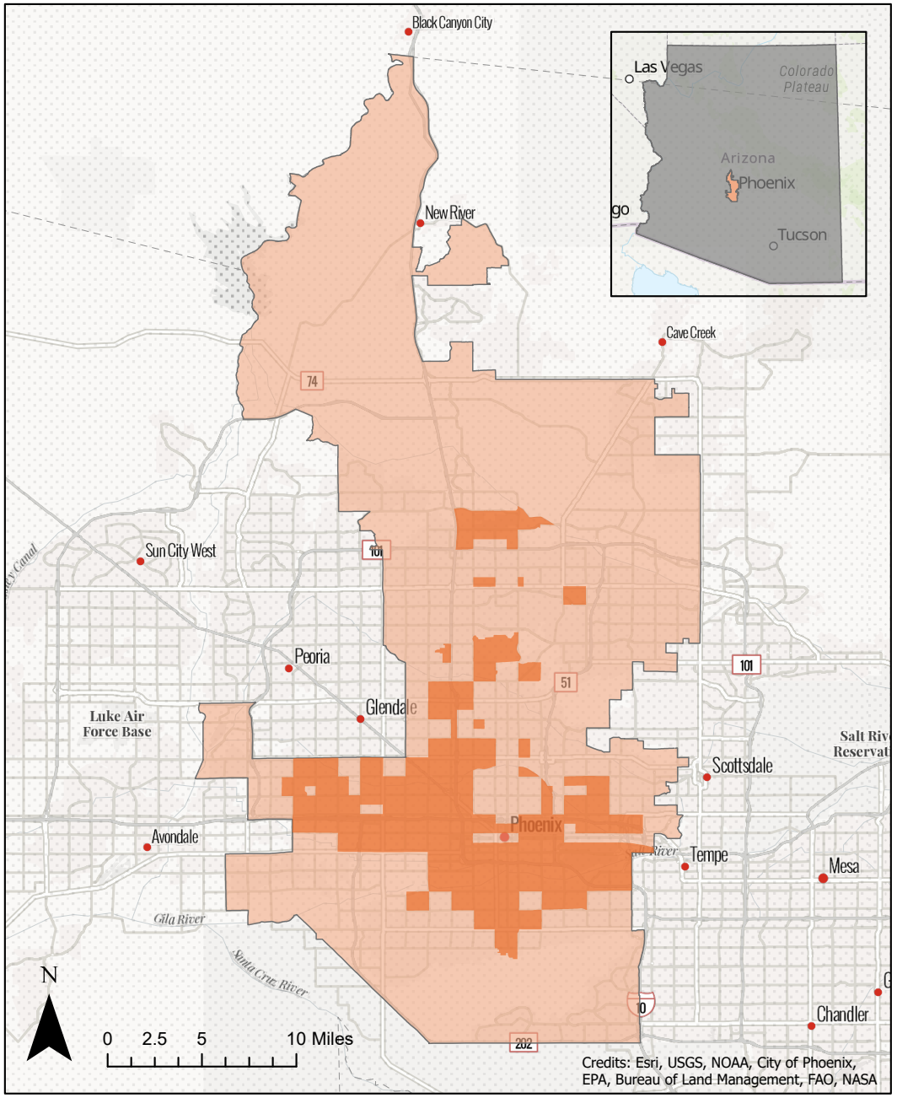

*Figure 1.* City of Phoenix in *light orange,* qualified census tracts in *dark orange.*

***2.2 Project Partners & Objectives***

The City of Phoenix has initiated green infrastructure programs and hopes to reach a city-wide average tree canopy cover of 25% by 2030 (City of Phoenix, 2010). To do so, the City of Phoenix Office of Heat Response and Mitigation, Office of Sustainability, and Streets Department have expanded tree planting initiatives to residential areas deemed most vulnerable to excess urban heat. We created a priority ranking system for census block groups within qualified census tracts (QCTs) of Phoenix and selected specific households that would be ideal candidates for their residential tree planting program. This ranking system addresses current areas of environmental and shade inequity by assessing existing tree canopy and land surface temperature (LST) at the census block group scale within QCTs. The ranking system also considers socioeconomic inequities and demographic data. The selection of households within the most vulnerable block groups depended on existing tree cover and the available land area to plant new trees. We developed public communication tools and graphics to aid in advocacy efforts for policy makers and increase buy-in from residents in need of increased tree cover on their properties. The city and other partners will use the ranking system and communication tools to identify vulnerable and tree-sparse residential neighborhoods for planting in order to create a more equitable tree canopy in Phoenix.

# 3. Methodology

***3.1 Data Acquisition***

*3.1.1 Social Vulnerability Index*

Informed by the Social and Heat Vulnerability Indices published by researchers at Arizona State University’s Global Institute of Sustainability and Innovation, the Social Vulnerability Index created by the CDC, and literature by Reid et al. (2009), we created a new social vulnerability index (SVI) for this project. We acquired data at the block group scale from the 2019 American Community 5-year Survey (ACS) through the US Census Bureau. Chosen variables describe the socioeconomic status, age, education, race, and household size of residents living in the block groups. The variables utilized in the index are listed in Table A1.

*3.1.2 Heat Data*

We utilized daytime land surface temperature (LST) as our main heat metric. Land surface temperature is how hot the surface of the Earth would feel to the touch in a particular location (NASA Earth Observatory). Through Google Earth Engine, we acquired all available Landsat 8 (LANDSAT/LC08/C01/T1_SR/TOA; U.S. Geological Survey, 2022) images of Phoenix during the hottest months, May through September, of 2015–2019. To assess other variables related to how people experience heat in an area, analysis of impervious surfaces was included in the heat vulnerability index. Through Google Earth Engine, the percent of impervious land cover was acquired as a band from the USGS Landsat 8 based National Land Cover Database (NLCD) for the year 2019 (USGS/NLCD_RELEASES/2019_REL/NLCD; Dewitz & U.S. Geological Survey, 2021).

*3.1.3 Tree Canopy Data*

We acquired tree canopy percent cover from American Forests through the TreeEquityScore.org project sourced from Earth Define’s US Tree Map. The data also included target canopy coverage based on generalized natural biome baseline targets selected in conjunction with the US Department of Agriculture Forest Service. These data are population weighted, so areas with denser population have lower canopy targets. However, neighborhoods that are in need of tree investments tend to be those that are denser and more populated, so this lower tree canopy target makes less sense; we were concerned that this lower tree canopy target would write-off the very neighborhoods we aimed to focus on. We chose to not use tree canopy cover targets and instead took a simpler approach of prioritizing areas with the least tree coverage. Tree canopy coverage from this dataset is displayed in Figure B1.

*3.1.4 Movement Data*

We acquired bus ridership data from the Valley Metro Open Data website. The data were average weekday and weekend boardings for each quarter from 2016 to 2019. We decided to focus on weekday boardings from the years 2018 and 2019.

We acquired pedestrian and biker movement and heat exposure data from Arizona State University’s Icarus model. Icarus is an activity-based model that, among other things, simulates the movement of people around Phoenix. The model was built using trips carried out by 3.8 million travelers on June 30th, 2017 for 24 hours. The data we used were from 1.2 million walking and biking trips, and we focused on segments traveled where the person experienced over 140°C mean radiant temperature (MRT).

*3.1.5 Parcel Level Analysis*

Parcel level analysis was dependent on the number of existing trees in each parcel, as well as the available land area not covered by a building that could be used to plant new trees. We acquired parcel data and zoning codes from the City of Phoenix. Building footprints were acquired from Bing Maps Microsoft Building Footprints. We used LiDAR-Derived Tree Locations (2014) from the Arizona State University Map and Geospatial Hub to find existing tree cover on each parcel.

***3.2 Data Processing***

*3.2.1 Social Vulnerability Index*

Utilizing the tidycensus package in R, we selected variables for the social vulnerability index from the ACS and manipulated them to display percentages rather than raw count. Each of these variables were then assigned a percentile rank from highest to lowest with the exception of per capita income, which is ranked lowest to highest. Per capita income was ranked from lowest to highest because, unlike the other variables, a higher value indicates lesser vulnerability. This ranking system was created using the percent_rank() function in R.

The percentile ranks of each variable were then normalized by population size. To do this, we multiplied each percentile rank by its population proportion for the respective geometries. This was an important step to ensure that block groups with a lower population, such as ones that are in an industrial zone, would have a lower score than block groups that have a relatively high population. The average of the normalized percentile ranks for each variable were then calculated to use for further analysis. The higher the social vulnerability score, the more vulnerable the community is to heat-related risks (Figure B2).

*3.2.2 Heat Data*

We used an open source LST calculation library (Ermida, 2020) to calculate LST from Landsat 8 images. We found the average summer LST for each block group in Phoenix (Figure B3). The median percent of impervious surface cover in 2019 for each census block group was found in Google Earth Engine using the NLCD.

*3.2.3 Movement Data*

From the bus ridership data, we found the total average work week (Monday – Friday) bus boardings for all bus stops within each block group (Figure B4). Using the pedestrian and biker movement from the Icarus model, we calculated a weighted total of trips traveled while experiencing > 140°C MRT in each block group. We weighed this total by the kilometers traveled in each trip to account for the length of time spent in outdoor heat by each traveler (Figure B5).

*3.2.4 Heat Vulnerability Index*

We computed our Heat Vulnerability Index (HVI) as a weighted mean of the aforementioned data for each block group (Equation 1).

$$\begin{aligned}\text{HVI} \text{=} \frac{\left(\text{SVI} \text{⋅ }\text{9} \text{+} \text{Tree} \text{Canopy} \text{⋅ }\text{5} \text{+} \text{LST} \text{+} \text{Impervious} \text{+} \text{Bus} \text{+} \text{BikePed} \text{Heat} \text{Exposure}\right)}{\text{18}}\#1\end{aligned}$$

We weighed the SVI by nine since it represented the value of nine socioeconomic variables. As the project was focused on increasing tree canopy in the city, we weighed tree canopy by five after testing multiple values and receiving our partner’s input (Figure 6B).

Determining the validity of a vulnerability index is important. In one study examining validity of social vulnerability models, it was found that the explanatory power of two widely accepted social vulnerability indices were lower than a weighted index based on expert knowledge when it came to outcomes in a natural disaster, specifically Hurricane Sandy (Rufat et al., 2019). The two methods were the Social Vulnerability Index from the University of South Carolina (SoVI) and the Social Vulnerability Index designed at the US Centers for Disease Control and Prevention (CDC SVI). The SoVI is an inductive index based on a principal components analysis (PCA), and the CDC SVI is a deductive index that ranks variables and sums rankings to create a score. Conversely, the weighted index is a hierarchical index where variables are grouped by pillar and then aggregated to create an index. The study found the explanatory power of the CDC SVI was poor, and the validity of the weighted index was higher than both (Rufat et al., 2019). One caveat is previous work having found hierarchical models, like the weighted index, highly sensitive to the weighting scheme (Tate et al., 2012). However, we still chose to model our HVI after the weighted index discussed in this literature because this approach has a major benefit of being more readable for the public and policy-makers trying to understand our method, as opposed to an inductive method like the SoVI that requires a PCA. The weighted model also allows us to preserve the differences in the data that we would lose if we were to use a ranked deductive approach like the CDC SVI.

*3.2.3 Parcel Level Analysis*

In order to make comparisons between different data layers, data not acquired from the City of Phoenix were reprojected to the Arizona coordinate system, 1983, central zone which the city uses. Then we clipped the LiDAR-derived tree points, parcels, and building footprints to include only single-family residence zones, as these residences are the most likely to be owner-occupied and participate in a residential tree-planting program in its initial stages. Any parcel without buildings, and therefore without homeowners, was ignored. The resulting parcels were then counted for each block group within QCTs. The City of Phoenix wanted to select around 20,000 single-family residences for the first round of tree-planting, hoping to garner about 25% participation from these homes. The block groups were ranked by their HVI score, and the first block groups containing 20,515 parcels were selected for analysis.

***3.3 Data Analysis***

*3.3.1 Neighborhood Spatial Clustering Analysis*

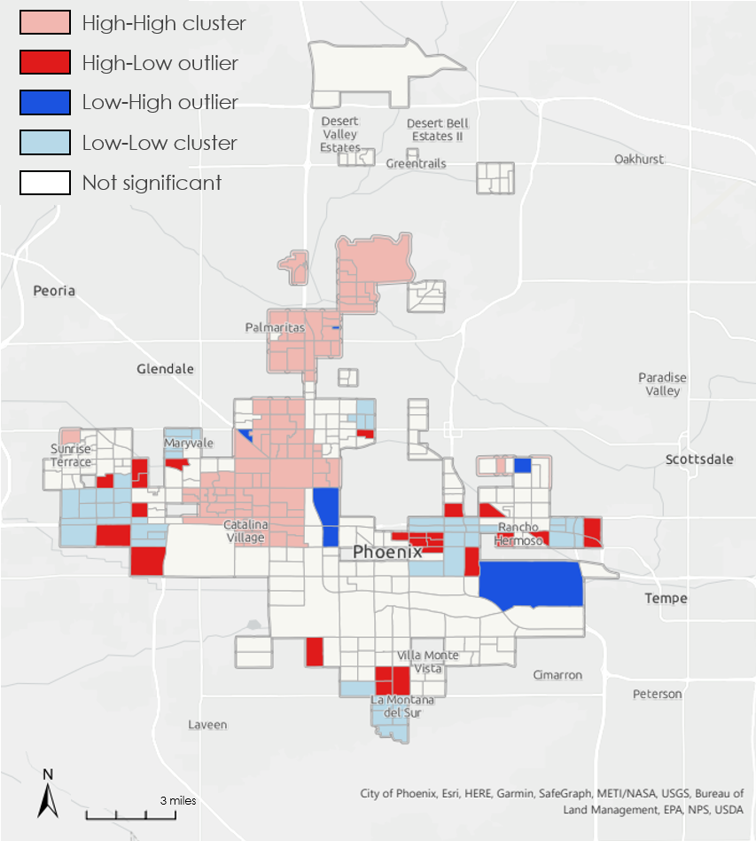

*Figure 2.* Anselin’s Local Moran’s I spatial clustering analysis of Phoenix block groups.

We sought to conduct a macro-scale analysis of our data and identified five neighborhoods within the QCTs that have some of the highest heat vulnerability score clusters. We ran Anselin’s (1995) Local Moran’s I spatial clustering analysis to highlight areas which have statistically significant clustering patterns, as well as to pull out any outliers (Figure 2). This analysis calculates z and p scores as measures of statistical significance. A high positive z-score for a block group indicates that the surrounding block groups have similar values. A High-High (HH) value indicates a statistically significant cluster of high values and a Low-Low (LL) value indicates a statistically significant cluster of low values. A low negative z-score indicates a block group is a spatial data outlier. A negative z-score indicates the block group has a high value but is surrounded by block groups with low values (HL), and vice versa for low values surrounded by block groups with high values (LH). This spatial clustering analysis is useful in visualizing more widespread patterns throughout the QCTs, aiding us in our neighborhood selection process.

*3.3.2 Parcel Analysis*

We developed a ranked list for the 20,515 parcels selected. The ranking criteria was based on the existing number of trees in each parcel, as well as the amount of available space for trees on each property. This “plantable area” was any area inside the parcel not covered by a building, which mostly included houses and sheds. The LiDAR-derived tree points from 2014 were counted within each parcel. We divided the total number of trees within each parcel by the parcel area to get the number of existing trees per square foot of the parcel, in order to account for parcels with differing amounts of space for existing trees. For the second ranking criteria, the total area of all buildings in each parcel was summarized. The total building area within a parcel was subtracted from the parcel area to find the potentially available plantable area for new trees.

# 4. Results & Discussion

***4.1 Analysis of Results***

*4.1.1 Neighborhood Spatial Clustering Analysis Results*

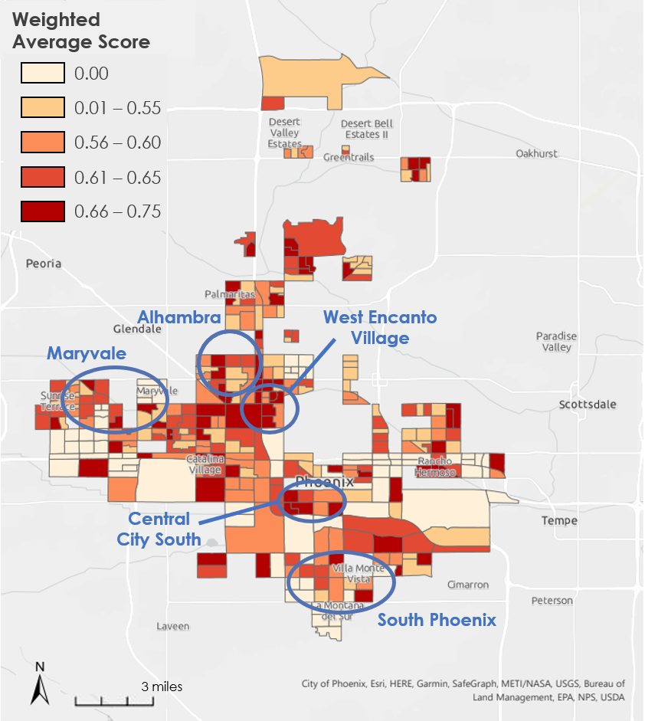

*Figure 3.* HVI weighted average scores of QCTs with labeled areas selected for tree planting: Alhambra, West Encanto Village, Maryvale, Central City South, and South Phoenix.

We decided to use Anselin’s (1995) Local Moran’s I analysis to inform spatial clustering pattern selection rather than as a definitive metric. Conducting a site suitability analysis on the neighborhood scale for the ARPA residential tree planting program from a purely quantitative lens fails to consider the historical background of each community. Therefore, our final neighborhood selection was achieved through clustering patterns we identified manually as well as considering the historical backgrounds of each area (Figure 3). Each neighborhood has a history of redlining, has inequitable opportunities to be included within heat mitigation programs, or is an area that the community has already begun engagement efforts in terms of tree canopy expansion. Additionally, each of these neighborhoods have an average heat vulnerability score of 0.6 or above, lying within the upper quantile of our data (Figure 4).

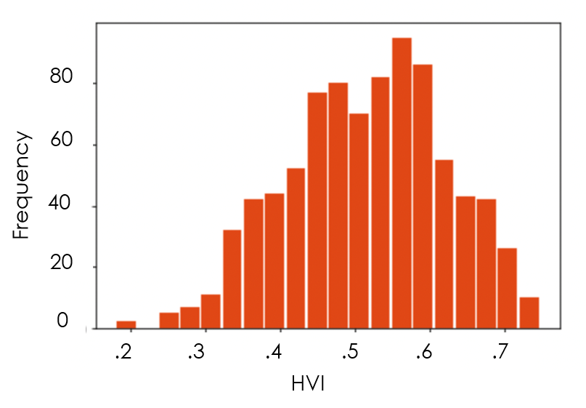

*Figure 4.* Distribution of Heat Vulnerability Index Score among block groups within QCTs.

The neighborhoods we have selected for larger scale tree planting initiatives are Alhambra, West Encanto Village, Maryvale, Central City South, and South Phoenix. Each neighborhood is characterized by socioeconomic and environmental factors that make communities more vulnerable to urban heat risks. Though increasing the tree canopy in this area does not mean that the larger systemic problems impacting these areas will be solved, it is a slow step in the right direction of employing environmental justice. Allocating funding to bettering the lived environment in these neighborhoods while ensuring that community leaders are involved in the shade canopy expansion process can ultimately lead to more heat resilient communities. The profiles of each selected neighborhood are outlined below.

Alhambra is known for its southwestern and Hispanic culture and is one of the most diverse neighborhoods in Phoenix. In the 1940s and 1950s, this neighborhood experienced a boom in population as military families stationed at the nearby Luke Airforce Base (City of Phoenix, n.d.). To appeal to these families on a military budget, lower income housing was constructed, much of it still standing today. The affordability keeps it in the low-income category, and many low-income areas are subject to crime. In some areas the crime rate can be 165% greater than the national average.

West Encanto Village is characterized by high poverty rates, with the majority of the population being non-white. The historic homes in this area are less likely to be well equipped with central air conditioning, therefore making residents more vulnerable to heat-related illnesses. This portion of Encanto Village differs from the rest because this area experiences higher daytime temperatures while having lower tree canopy coverage.

Maryvale is a master-planned community on the southwest side of Phoenix that took shape in the 1950s when its developer aimed to create a suburb with affordable homes and space for parks, schools, and community services (Pratcher Ii, 2017). Over the years, the community fell on hard times with increasing crime and blight. Thus, Maryvale is now a community characterized by high poverty rates, low high school graduation rates, and an underdeveloped tree canopy.

Central City South is an area known to have been affected by historical redlining acts, resulting in high poverty rates, crowded living conditions, and low tree canopy coverage (Digital Scholarships Lab, n.d.). Due to its proximity to the city, many individuals here don’t own a vehicle and rely on public transit to navigate the city. This means that those who live here are more likely to spend more time outdoors, further increasing their vulnerability to heat related risks.

South Phoenix is known for post war homes and being one of the least expensive areas to purchase a home in the valley. It is the most diverse and socio-economically challenged area of Phoenix as a result of historic racial exclusion, class domination, political disenfranchisement, and a racially segmented economy. These factors have been materialized in distinct land-use and socio-economic patterns in the neighborhood (Bolin et al., 2005).

*4.1.2 Parcel Analysis Results*

We used a sample of single-family parcels from the 25 block groups with the highest HVI scores in order to determine the attributes of parcels that may be most in need of tree-planting. In these 25 most vulnerable block groups, there were 2,411 single-family parcels with buildings. In these block groups, the top 100 parcels of low existing tree cover and high available area for planting were found in just 10 block groups. As an example of the types of parcels this methodology selected, we can see from just a small section of one block group in northern Phoenix that the parcels selected in red in fact look fairly tree-sparse compared to their neighbors (Figure 5).

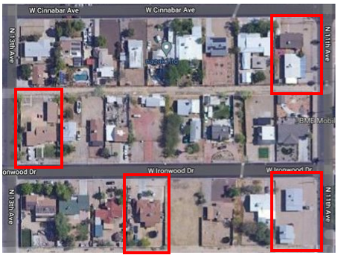

*Figure 5.* Example of parcels selected with our methodology in one of the 25 most vulnerable block groups.

Within the 2,411 parcels analyzed, there were 3,133 trees (Figure 6). The number of trees per parcel with a building ranged from 0–33, with an average of 1.3 trees per parcel. Half of the parcels analyzed had 1 tree or no trees, and only 7 parcels had more than 10 trees. These large parcels were typically made up of multiple single-family homes on a single parcel. 835 of these parcels had 0 trees according to the 2014 LiDAR-derived tree points. 90% of homes in these parcels had 3 or fewer trees, so homes with 2 or fewer trees (the 75th percentile) were considered high-priority.

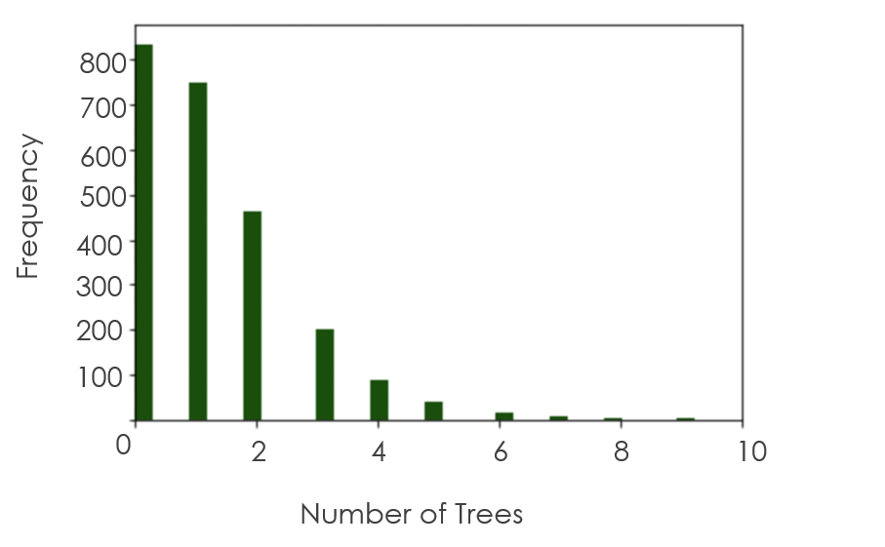

*Figure 6.* Distribution of the number of trees per parcel in the 25 most vulnerable block groups. Outliers above the 99th percentile were excluded for ease of plotting.

Available area (i.e., not covered by a building) in each parcel ranged from 686 to just under 250,000 square feet (Figure 7). The large parcels were again parcels with multiple single-family residences on one parcel. The average available land area in these parcels was 5,172 square feet, and 95% of these parcels had under 7,500 square feet of available land area. Most (75%) of these parcels had less than 5,500 square feet of available area, so parcels with above that amount were prioritized for tree planting.

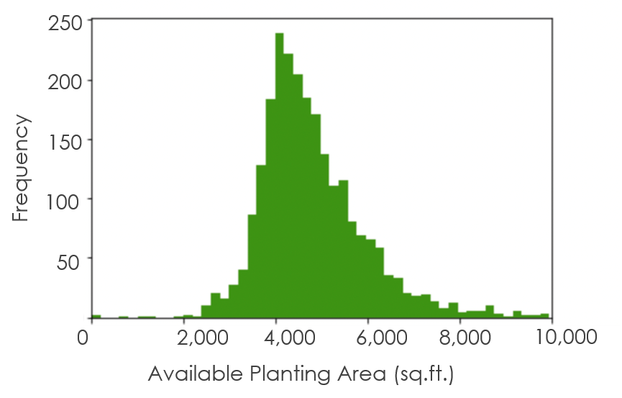

*Figure 7.* Distribution of available land area on each parcel within the 25 most vulnerable block groups. Outliers above the 99th percentile were excluded for ease of plotting.

All 20,515 single-family parcels had similar distributions to the most vulnerable block group 2,411-parcel subset previously analyzed. Of all parcels in every QCT defined block group, the mean number of trees on each parcel was 1.3 and the average amount of available land area on each parcel was 5,976 square feet. The distribution of trees on each parcel was very similar to the most vulnerable 2,411 block groups analyzed, as the median was also 1 tree per parcel and the third quartile was 2 trees per parcel. The distribution of available land area on each parcel was more skewed to larger parcels, as the median available area in each parcel was 4,624 square feet and the third quartile was 5,480 square feet.

To develop a parcel-level ranking for the city, we ordered all 20,515 parcels by ascending existing tree canopy and then descending available land area to get a list of the top parcels lacking trees with the highest planting space available. Any parcel with less than 2 trees and 5,500 square feet or more was added to a high-priority list. These high-priority criteria were based on the 75th percentile of all 20,515 parcels in the analysis.

***4.2 Limitations & Uncertainties***

Limitations of the data were largely products of desired high spatial resolution of the data. The American Community Survey is a good tool for general demographic trends, but it has high standard error when applied at a finer resolution (i.e., census blocks). Additionally, the variables that confer heat vulnerability in one location may not be translatory to another location, especially with Phoenix's unique trends of urban heat vulnerability within an arid desert. Land surface temperature was the limiting factor of finer spatial analysis for this study. Additional temperature datasets are available, such as MRT, but these are limited in scope and not proper for a residential plot analysis. Upon visual spot checks with satellite imagery, building data were found to be mostly accurate but missed some building types, such as trailer homes. We also could see more trees than were represented in the LiDAR-derived tree points last updated in 2014. Additionally, tree cover as points limits the scope of analysis possible, as tree cover isn't easily estimated in the parcels. Lastly, quantitative analysis of urban heat is useful as a tool but cannot replace community engagement and lived experiences of Phoenix residents. Our data showing heat-vulnerable areas should be used as a starting point for more qualitative analysis of these areas.

These limitations to the data may be resolved with community outreach and field surveys, especially to determine the validity and currency of our parcel analysis. The creation of a ranked list of many parcels will give the city flexibility to determine the most valid top-priority parcels by having the ability to move down the list systematically if different results are found on the ground.

***4.3 Future Work***

These findings will be given to the City of Phoenix as part of the American Rescue Plan Act tree planting program. These methods may also be helpful for determining future priority areas for cool corridor, cool pavement, or other heat mitigation strategies. In addition, this methodology may be expanded to determine parcel rankings of larger areas of the city, and it could include the analysis of other residential areas not prioritized in this study, such as multifamily residential buildings.

Future work and expansion on our analysis could include finding relationships between socioeconomic, heat, and tree cover variables by conducting a principal component analysis (PCA). A team could also experiment with using inductive or deductive methods for finding a heat vulnerability index. In addition, models such as ENVI-met could be used to determine neighborhood heat mitigation impacts of proposed tree planting locations on the parcel level

Beyond our quantitative analysis, considering procedural justice further would be important future work. This could include engaging with community-based organizations to ensure that community members and voices are uplifted and included in the planning process.

# 5. Conclusions

The methods used in this study applied principles from heat vulnerability research to the city's specific needs for heat mitigation in residential areas. In doing so, five areas were identified as candidates for this tree planting program, as they were the most feasibly accessible clusters of highly vulnerable block groups. In the most vulnerable 25 block groups, there were 3,133 trees on the 2,411 single family residential parcels analyzed. In order to triple the tree cover on these parcels, about 9,400 more trees would be needed. In all 20,515 single-family parcels analyzed, there were 28,204 trees. It is difficult to estimate the current percentage of land shaded by these trees because our parcel analysis was limited to trees as points, however, if the city aims to triple tree canopy in all block groups of this analysis, about 80,000 additional trees may be needed. As the city is estimating 25% participation in this program from residences, it is important to note the bottom quartile of tree count in all parcels was zero trees, so even adding one tree to the most tree-sparse 5,000 parcels would change the distribution of tree canopy in QCT block groups remarkably.

These results set a priority for all block groups within Phoenix's qualified census tracts, so the program may be able to expand past the initial selected areas. Additionally, the methods used for cluster and parcel selection are adaptable to include more and different parcel types in the future. The city will be able to use the ranked list of block groups and parcels, as well as the high-priority parcel list, to aid in collecting field observations of these areas in an efficient manner.

Using these identified parcels as a starting point for the ARPA Residential Tree Planting program will help address shade inequity and the community concerns around disparities in shade cover between Phoenix neighborhoods. In addition, if implemented and trees are planted, long-term maintenance of trees and other cooling infrastructure ensures that communities gain long term benefits.

# 6. Acknowledgments

We would like to extend a special thank you to our Science Advisors, Mentors, and Fellow for their direction and support:

· Dr. David Hondula (Arizona State University, City of Phoenix)

· Lance Watkins (Arizona State University)

· Ryan Hammock (NASA DEVELOP, Fellow/Lead)

· Michelle Litwin (City of Phoenix)

Any opinions, findings, and conclusions or recommendations expressed in this material are those of the author(s) and do not necessarily reflect the views of the National Aeronautics and Space Administration.

This material is based upon work supported by NASA through contract NNL16AA05C.

# 

# 7. Glossary

**ACS** – American Community Survey; conducted annually by the U.S. Census Bureau to provide frequent estimates about socioeconomic attributes of communities

**Albedo** – the fraction of light that is reflected by a surface

**Cooling Capacity** – a measure of a system’s ability to remove heat

**Earth Observations** – Satellites and sensors that collect information about the Earth’s physical, chemical, and biological systems over space and time

**ENVI-met** – software that simulates the microclimate of urban areas at fine scales and provides multiple tools to analyze multiple facets of the microclimate complex

**Environmental Justice** – the fair treatment and meaningful involvement of all people regardless of race, color, national origin, or income with respect to the development, implementation and enforcement of environmental laws, regulations, and policies

**Evapotranspiration** – the sum of evaporation of water from land and other surfaces and through transpiration by plants

**MRT** – Median Radiant Temperature; a measure of the average temperature of the surfaces that surround a particular point, with which it exchanges thermal radiation

**QCT** – Qualified Census Tract; a census tract that is eligible for the Low-Income Housing Tax Credit because at least 50% of its households have incomes below 60% of the Area Median Gross Income or because there is a poverty rate of 25% or more

# 8. References

American Forests. (n.d.). *Tree equity score data sources*. Tree Equity Score. https://www.treeequityscore.org/datasources/

Anselin, L. (1995). Local indicators of spatial association—LISA. *Geographical Analysis*, *27*(2), 93–115. https://doi.org/10.1111/j.1538-4632.1995.tb00338.x

Bolin, B., Grineski, S., & Collins, T. (2005). The geography of despair: Environmental racism and the making of South Phoenix, Arizona, USA. *Human Ecology Review*, *12*(2), 156–168.https://www.humanecologyreview.org/pastissues/her122/bolingrineskicollins.pdf

CDC/ATSDR. (March 2020). Social Vulnerability Index. https://www.atsdr.cdc.gov/placeandhealth/svi/index.html

City of Phoenix. (2010). Tree and Shade Master Plan. https://www.phoenix.gov/parkssite/Documents/PKS_Forestry/PKS_Forestry_Tree_and_Shade_Master_Plan.pdf

City of Phoenix. (n.d.). *Alhambra.* https://www.phoenix.gov/villages/alhambra#:~:text=The%20Alhambra%20Village%20area%20grew,to%20the%20west%20of%20town.

Dewitz, J., & U.S. Geological Survey. (2021). *National Land Cover Database (NLCD) 2019 Products* (ver. 2.0) [Data set]. U.S. Geological Survey data release. https://doi.org/10.5066/P9KZCM54

Digital Scholarship Lab. *Mapping Inequality: Redling in New Deal America*. (n.d). https://dsl.richmond.edu/panorama/redlining/#loc=13/33.443/-112.085&amp;city=phoenix-az&amp;area=D5

Ermida, S. L., Soares, P., Mantas, V., Göttsche, F.-M., & Trigo, I. F. (2020). Google Earth Engine open-source code for Land Surface Temperature estimation from the Landsat series. *Remote Sensing*, *12*(9), Article 1471. https://doi.org/10.3390/rs12091471

Flanagan, B. E., Gregory, E. W., Hallisey, E. J., Heitgerd, J. L., & Lewis, B. (2011). A social vulnerability index for disaster management. *Journal of Homeland Security and Emergency Management*, *8*(1). https://doi.org/10.2202/1547-7355.1792

Golden, J. S. (2004). The built environment induced urban heat island effect in rapidly urbanizing arid regions – A sustainable urban engineering complexity. *Environmental Sciences*, *1*(4), 321–349. https://doi.org/10.1080/15693430412331291698

Harlan, S. L., Declet-Barreto, J. H., Stefanov, W. L., & Petitti, D. B. (2013). Neighborhood effects on heat deaths: Social and environmental predictors of vulnerability in Maricopa County, Arizona. *Environmental Health Perspectives*, *121*(2), 197–204. https://doi.org/10.1289/ehp.1104625

Kenny, G. P., Yardley, J., Brown, C., Sigal, R. J., & Jay, O. (2010). Heat stress in older individuals and patients with common chronic diseases. *Canadian Medical Association Journal*, *182*(10), 1053–1060. https://doi.org/10.1503/cmaj.081050

Martilli, A., Krayenhoff, E. S., & Nazarian, N. (2020). Is the urban heat island intensity relevant for heat mitigation studies? *Urban Climate*, *31*, Article 100541. https://doi.org/10.1016/j.uclim.2019.100541

Maier, G., Grundstein, A., Jang W., Li, C., Naeher, L. P., & Shepherd, M. (2014). Assessing the performance of a vulnerability index during oppressive heat across Georgia, United States. *Weather, Climate, and Society*, *6*(2), 253–263. https://doi.org/10.1175/WCAS-D-13-00037.1

Middel, A., Lukasczyk, J., & Maciejewski, R. (2017). Sky View Factors from synthetic fisheye photos for thermal comfort routing—A case study in Phoenix, Arizona. *Urban Planning*, *2*(1), 19–30. https://doi.org/10.17645/up.v2i1.855

Mitraka, Z., & Chrysoulakis, N. (2018). Earth Observation for Urban Climate Monitoring: Surface Cover and Land Surface Temperature. In R. B. Rustamov, S. Hasanova, & M. H. Zeynalova (Eds.), *Multi-purposeful Application of Geospatial Data.* IntechOpen. https://doi.org/10.5772/intechopen.71986

NASA. (2020, March 17). *Environmental justice*. NASA NEPA Programs. https://www.nasa.gov/emd/environmental-justice

NASA Earth Observatory. (n.d.). *Land surface temperature*. NASA. Retrieved March 22, 2022, from https://earthobservatory.nasa.gov/global-maps/MOD_LSTD_M

Nowak, D. J., Hoehn, R. E. III, Crane, D. E., Stevens, J. C., & Walton, J. T. (2007). *Assessing urban forest effects and values, New York City's urban forest.* U.S. Department of Agriculture, Forest Service, Northern Research Station. https://doi.org/10.2737/NRS-RB-9

Pratcher Ii, A. C. (2017). *Community Consumed: Sunbelt Capitalism, A Praxis For Community Control, And The (dis) Integration Of Civic Life In Maryvale, Arizona.* Publicly Accessible Penn Dissertations. 2536.

Reid, C. E., O'Neill, M. S., Gronlund, C. J., Brines, S. J., Brown, D. G., Diez-Roux, A. V., & Schwartz, J. (2009). Mapping community determinants of heat vulnerability. *Environmental health perspectives*, *117*(11), 1730–1736. https://doi.org/10.1289/ehp.0900683

Rufat, S., Tate, E., Emrich, C., & Antolini, F. (2019). How valid are social vulnerability models? *Annals of the American Association of Geographers*, *109*(4), 1131–1153. https://doi.org/10.1080/24694452.2018.1535887

Tate, E., Strong, A., Kraus, T., & Xiong, H. (2016). Flood recovery and property acquisition in Cedar Rapids, Iowa. *Natural Hazards*, *80*(3), 2055–2079. https://doi.org/10.1007/s11069-015-2060-8

U.S. Census Bureau. (2022). *Quick Facts Phoenix, AZ.* https://www.census.gov/quickfacts/phoenixcityarizona

U.S. Census Bureau. (2019). American Community Survey 5-Year Data, 2015-2019. Retrieved from https://www.census.gov/data/developers/data-sets/acs-5year.html

U.S. Geological Survey. (2022). *Landsat 8 Operational Land Imager (OLI) & Thermal Infrared Sensor (TIRS).* https://doi.org /10.5066/F71835S6

Wang, Z. H., Zhao, X., Yang, J., & Song, J. (2016). Cooling and energy saving potentials of shade trees and urban lawns in a desert city. *Applied Energy*, *161*, 437–444. https://doi.org/10.1016/j.apenergy.2015.10.047

Wen, M., Zhang, X., Harris, C. D., Holt, J. B., & Croft, J. B. (2013). Spatial disparities in the distribution of parks and green spaces in the USA. *Annals of behavioral medicine: a publication of the Society of Behavioral Medicine*, *45*(Suppl 1), S18–S27. https://doi.org/10.1007/s12160-012-9426-x

Wright, M., Watkins, L., Hondula, D., Kurtz, L., Chakalian, P., Harlan, S., & Declet-Barreto, J. (2019). *Social and Heat Vulnerability Indices in Phoenix, Arizona*. Retrieved February 21, 2022, from https://sustainability-innovation.asu.edu/caplter/data/view/knb-lter-cap.665.2/

# 9. Appendices

**Appendix A**

Table A1

*Variables acquired to inform our Social Vulnerability Index. All variables contain one value per block group polygon.*

|  |  |
| --- | --- |
| **Variable** | **Data Source** |
| Total Population | 2019 5-year  American Community Survey |
| Percent of Population with No Vehicle Available |
| Percent of Population Unemployed |
| Percent of Population Ages 65+ |
| Percent of Population Ages 9 and Under |
| Percent of Population with Income Below Poverty Line |
| Percent of Population Ages 25+ with No Highschool Diploma |
| Percent Non-White |
| Per Capita Income |
| Percent of Population Living in Accommodations W/ Less Than 1 Room Per Person (Crowding) |

**Appendix B**

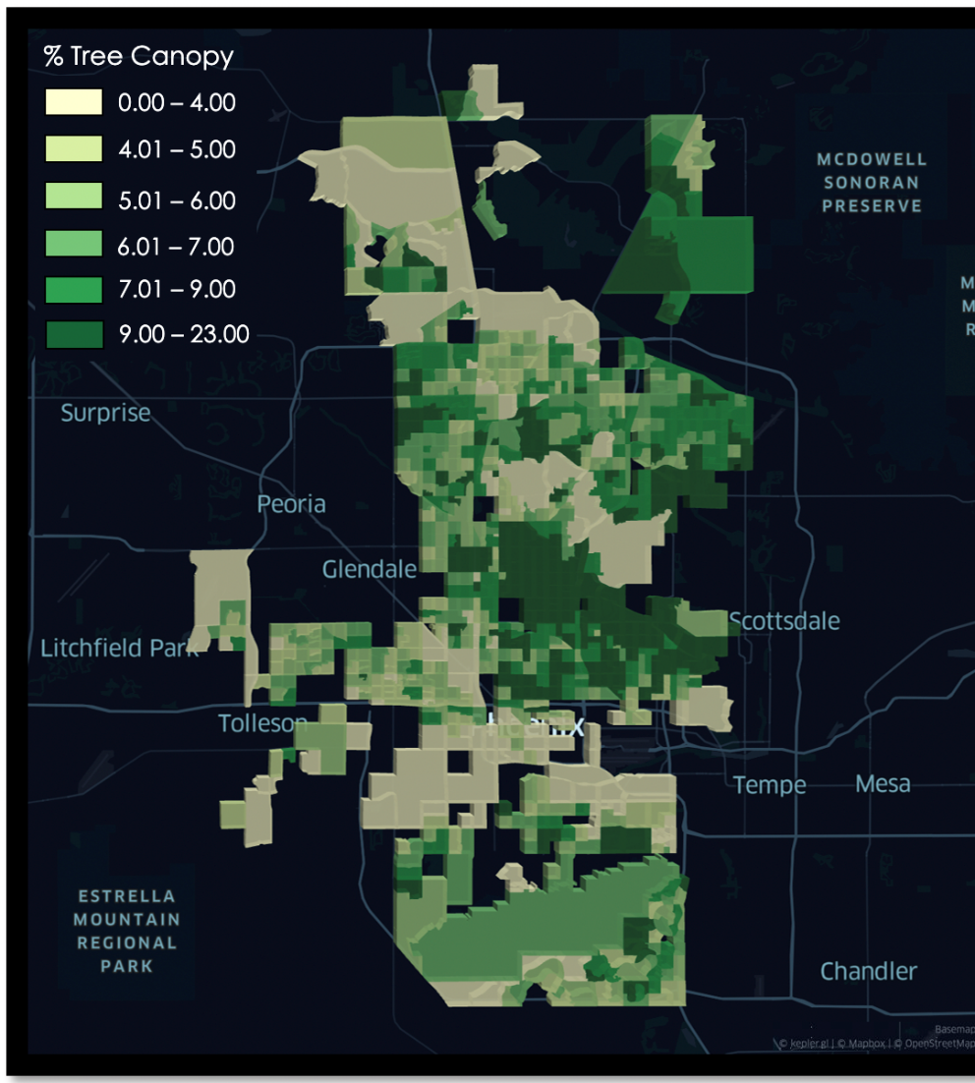

*Figure B1*. Phoenix tree canopy percentages.

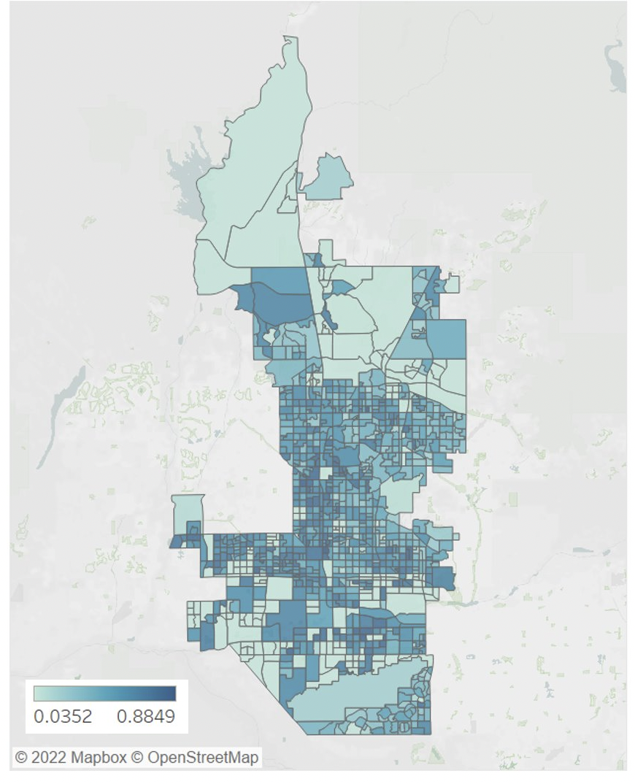

*Figure B2*. Phoenix Social Vulnerability Index. The higher the social vulnerability score, the more vulnerable the community is to heat-related risks.

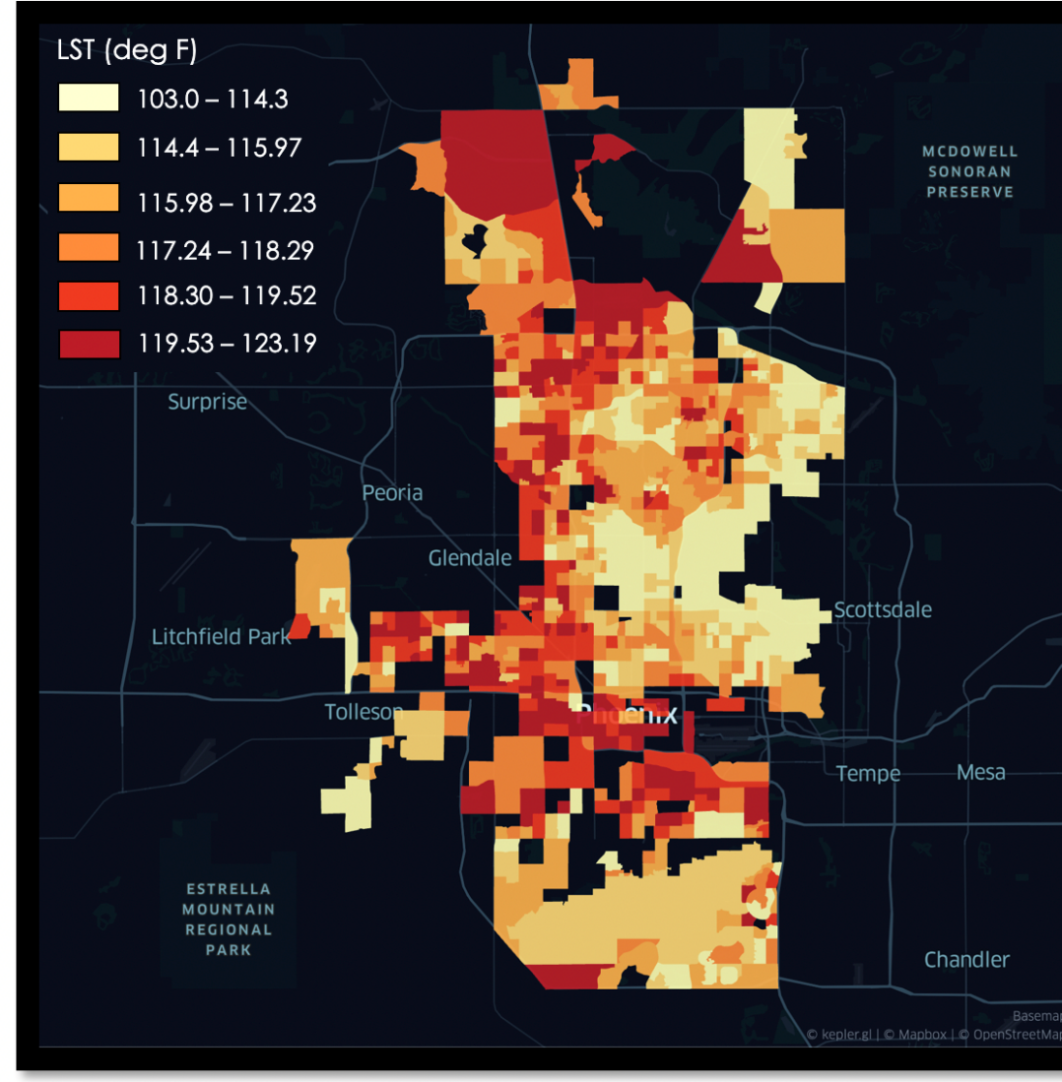

*Figure B3*. Average summer LST for each block group in Phoenix.

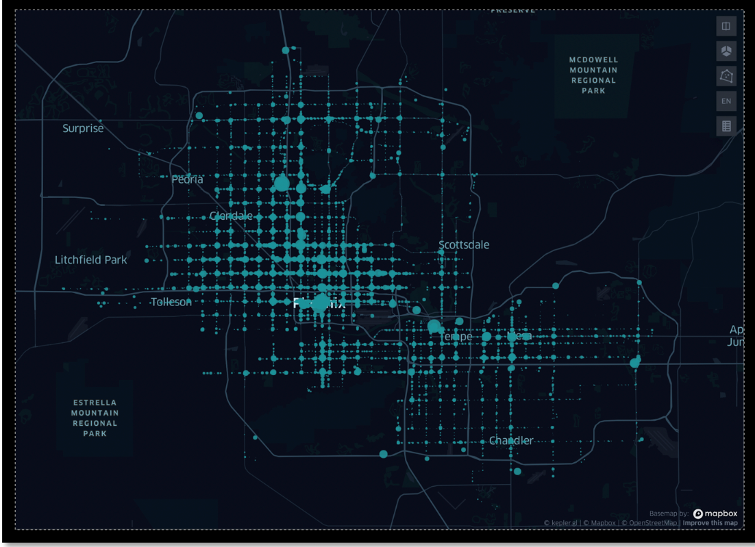

*Figure B4*. Phoenix bus ridership according to bus stop boardings.

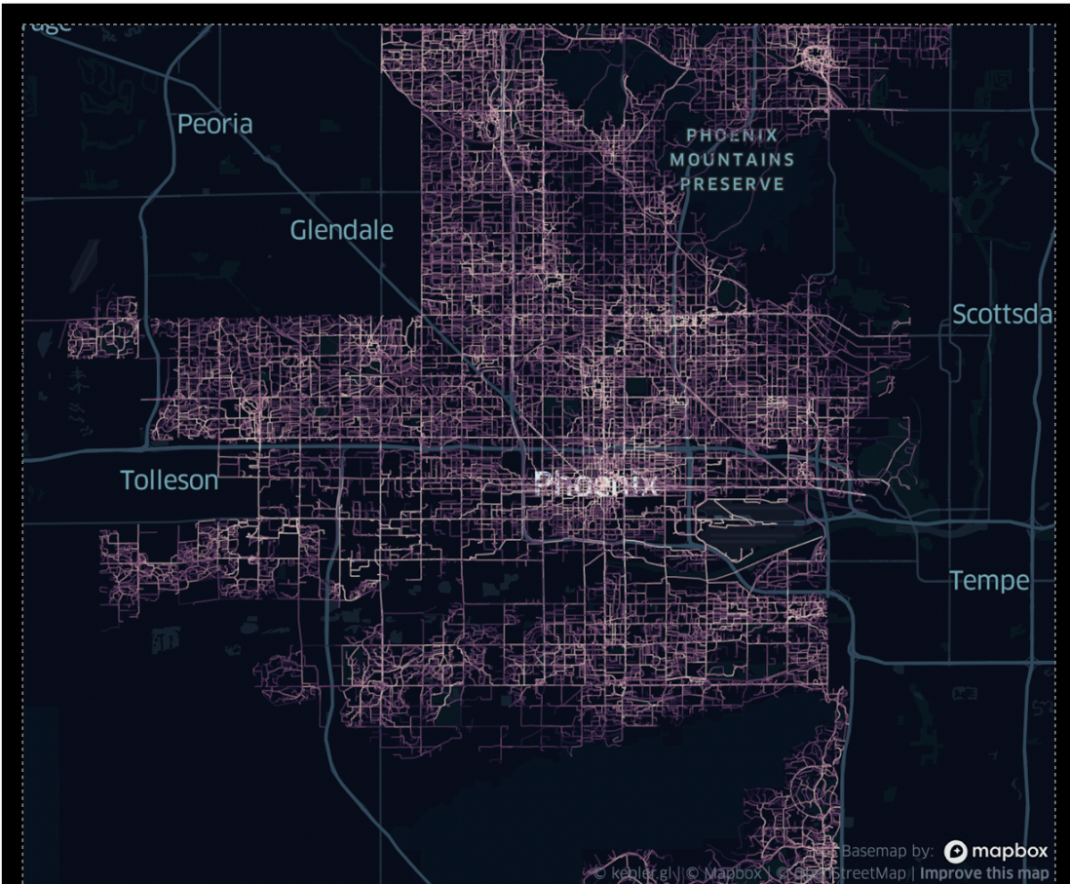

*Figure B5*. Pedestrian and bike mobility in Phoenix.

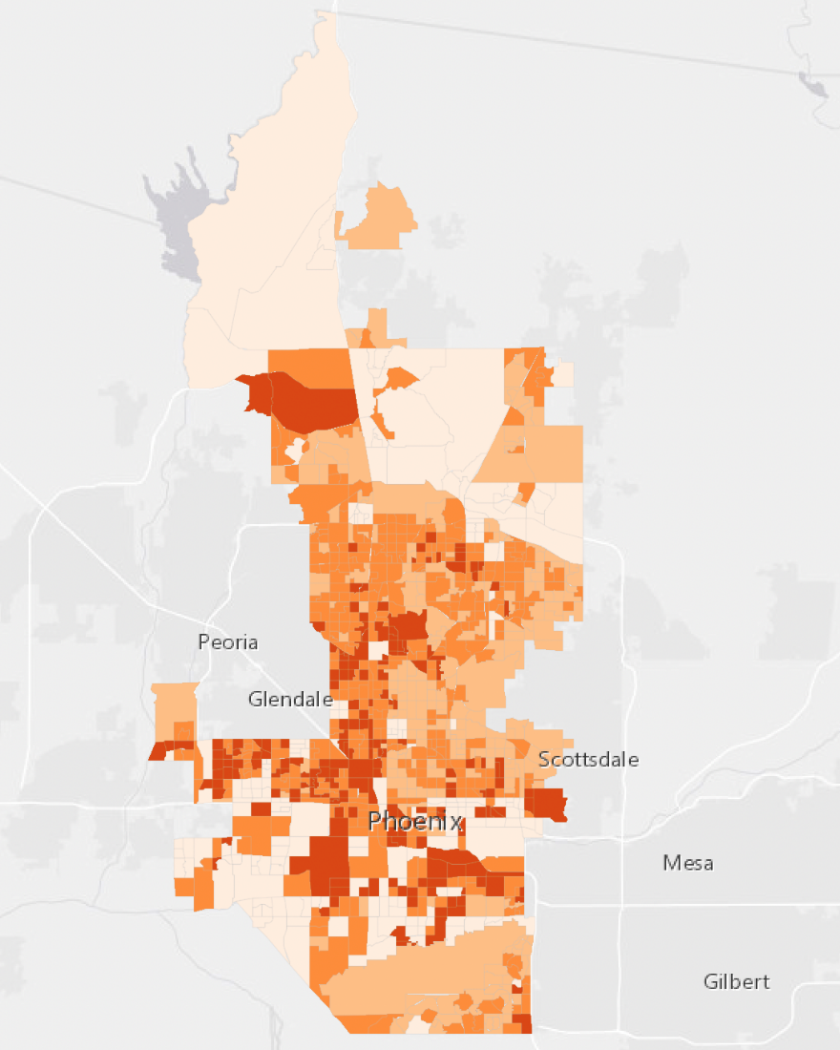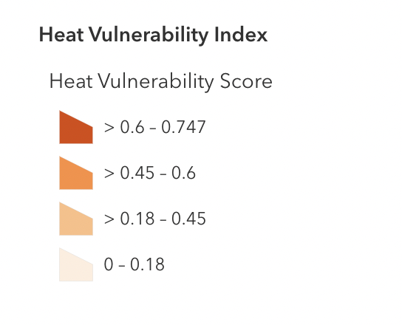

*Figure B6*. Phoenix Heat Vulnerability Index.